

**DIVISION OF DATA SCIENCE AND CYBER SECURITY**

**SCHOOL OF ENGINEERING AND TECHNOLOGY**

**SKILL BASED EVALUATION REPORT**

**SUBMITTED BY**

**HARIHARAN K (URK22AI1048)**

**Guided by**

**Mr. Sudhir K.**

**COURSE CODE  
20CS2014**

**COURSE NAME**

**DATA VISUALIZATION**

**October 2024**

**ACKNOWLEDGEMENT**

First and foremost, I praise and thank ALMIGHTY GOD whose blessings have bestowed in me the will power and confidence to carry out my project.

I am grateful to our beloved founders Late**. Dr. D.G.S. Dhinakaran, C.A.I.I.B, Ph.D** and **Dr. Paul Dhinakaran, M.B.A, Ph.D**, for their love and always remembering us in their prayers.

I extend my thanks to our Vice Chancellor **Dr. Prince Arulraj, M.E., Ph.D.,** and our Registrar **Dr. S. J. Vijay, M.E., Ph.D,** for giving me this opportunity to do the project.

I wish to extend my thanks to our Pro-Vice Chancellors, **Dr. E.J. James**, **Dr. Ridling Margaret Waller** and **Dr. Elijah Blessing**, for providing me this opportunity to do the project.

I would like to thank **Dr. Ciza Thomas.,** Dean, School of Computer Science and Technology for his direction and invaluable support to complete the same.

I would like to place my heart-felt thanks and gratitude to **Dr. Grace Mary Kanaga E, M.Tech., Ph.D.,** Head of the Division, Data Science and Cyber Security for her encouragement and guidance.

I feel it is a pleasure to be indebted to, Mr. Sudhir K for the invaluable support, advice and encouragement.

I also thank all the staff members of the Division for extending their helping hands to make this project a successful one.

I would also like to thank all my friends and my parents who have prayed and helped me during the project work.

**TITLE: Hospital Emergency Room**

**ABSTRACT**

The **Hospital Emergency Room Dashboard** is a data-driven tool designed to provide a comprehensive overview of emergency room performance within a hospital setting. It visually represents key metrics like patient volume, average wait times, satisfaction scores, referrals, and demographic breakdowns, enabling a detailed analysis of ER efficiency and patient care quality.

Key features include:

1. **Patient Volume**: A line chart showing daily patient visits, helping to identify peak periods.
2. **Average Wait Time**: A time-series chart tracking how long patients wait for care, measuring ER efficiency.
3. **Patient Satisfaction**: A scorecard displaying satisfaction levels, correlating with wait times and service quality.
4. **Referrals**: A bar chart illustrating patient referrals to various departments, providing insights into care pathways.
5. **Demographics**: Charts showing patient breakdowns by gender, age, and race, highlighting trends in ER visits.
6. **Care Timeliness**: A donut chart showing the percentage of patients seen within 30 minutes.

The dashboard helps **administrators** and **healthcare professionals** make data-driven decisions by identifying trends, performance gaps, and areas for improvement. It serves as a vital tool for improving emergency medical services, patient experience, and hospital efficiency.

**INTRODUCTION**

In today’s rapidly evolving healthcare landscape, ensuring the quality and efficiency of **emergency room services** has become a critical concern for hospitals, healthcare administrators, and the general public. As demand for timely and effective emergency care grows, data analytics has emerged as a powerful tool for assessing and improving emergency room performance. Emergency rooms serve as essential gateways to healthcare, and their ability to provide rapid, high-quality care has a significant impact on patient outcomes and overall public health. In this context, the **Hospital Emergency Room Dashboard** is designed to facilitate the visualization and analysis of key performance indicators (KPIs) related to emergency care.

**Purpose of the Dashboard**

The **Hospital Emergency Room Dashboard** is a dynamic, interactive platform that provides a comprehensive overview of various emergency room performance metrics. The purpose of this dashboard is to offer a data-driven approach to evaluating ER operations, enabling healthcare professionals, administrators, and policymakers to assess ER performance at both detailed and holistic levels. This tool is particularly valuable for identifying trends, pinpointing areas for improvement, and making informed decisions based on real-time data.

By aggregating large volumes of ER-related data and presenting it in an accessible and visually appealing format, the dashboard simplifies complex performance monitoring by focusing on key metrics such as patient volume, wait times, referrals, and patient satisfaction.

**Components of the Dashboard**

The **Hospital Emergency Room Dashboard** incorporates several key components to provide a comprehensive view of emergency room performance:

1. **Patient Volume**: The dashboard tracks the number of patients visiting the ER, providing insights into daily, weekly, and monthly trends. This allows users to identify peak hours and days, helping to optimize staffing and resource allocation.
2. **Average Wait Times**: A critical component of the dashboard is the average wait time metric, which shows how long patients are waiting before receiving medical attention. This helps to evaluate the efficiency of emergency services and identify bottlenecks in patient flow.
3. **Patient Admission Status**: The dashboard provides a breakdown of patients based on their admission status (admitted vs. not admitted). This component gives insights into how many ER patients require further hospitalization, reflecting the severity of cases treated.
4. **Referral Patterns**: A bar chart showing the number of patients referred to different departments such as cardiology, orthopedics, and general practice. This component helps to track the flow of patients to various specialties, highlighting key referral trends.
5. **Care Timeliness**: The percentage of patients seen within 30 minutes is a key performance indicator. This component helps assess how well the ER meets critical care timelines, ensuring that patients receive timely medical attention.
6. **Patient Demographics**: Charts displaying patient breakdowns by **gender, age group, and race** provide a deeper understanding of who uses ER services, helping to identify trends and healthcare needs across different population groups.

By focusing on these critical components, the dashboard serves as a powerful tool for evaluating and improving emergency room services, allowing administrators to make data-driven decisions and enhance patient care.

**DATASET DESCRIPTION**

The dataset used in the **Hospital Emergency Room Dashboard** provides a comprehensive overview of various emergency room-related performance metrics. It includes key attributes that allow users to analyze the quality, efficiency, and effectiveness of emergency care services. Below is a breakdown of the key columns and data fields contained in the dataset:

1. **Patient ID**:
   * A unique identifier assigned to each patient.
   * Useful for tracking individual patients and distinguishing between various visits.
2. **Admission Status**:
   * Indicates whether a patient was admitted to the hospital or discharged after their ER visit.
   * Helps to analyze the percentage of emergency cases that require hospitalization.
3. **Patient Age Group**:
   * Categorizes patients into different age groups (e.g., 1-10, 21-30, 41-50, etc.).
   * Useful for analyzing the demographics of ER visits and understanding which age groups require the most emergency services.
4. **Gender**:
   * Specifies the gender of the patient (e.g., Male, Female, Non-Conforming).
   * Allows for gender-based analysis of emergency room usage and outcomes.
5. **Referral Department**:
   * The department to which the patient was referred (e.g., Orthopedics, Cardiology, Neurology).
   * Helps to track the flow of patients from the ER to specialized care departments.
6. **Average Wait Time**:
   * The average time (in minutes) patients wait before receiving medical attention in the ER.
   * A key metric for assessing the efficiency of emergency room operations.
7. **Patient Satisfaction Score**:
   * A rating (1 to 10) provided by patients based on their experience in the ER.
   * Indicates the level of satisfaction with care and services received.
8. **Number of Patients by Weekday and Hour**:
   * Shows the distribution of patients based on the day of the week and the hour of the day.
   * Useful for identifying peak times and improving staffing and resource allocation.
9. **Number of Patients by Race**:
   * Classifies patients based on their race (e.g., White, African American, Asian).
   * Allows for demographic analysis to identify trends and disparities in emergency care.
10. **Seen Within 30 Minutes**:
    * The percentage of patients seen within 30 minutes of arrival.
    * Measures the timeliness of care, a critical factor in emergency services.
11. **Number of Patients Referred**:
    * The total number of patients referred to other departments or specialists after the ER visit.
    * Provides insights into the severity and complexity of cases handled by the ER.

This dataset allows for a detailed analysis of emergency room performance, helping administrators and healthcare professionals to identify trends, address operational inefficiencies, and improve patient care.

**DASHBOARD DESIGN AND METHODOLOGY**

The Hospital Emergency Room Dashboard is designed to provide an interactive, visually intuitive platform for analyzing hospital emergency room performance. The dashboard integrates several visual elements to enable users to explore critical metrics like patient satisfaction, average wait times, and emergency services availability. The methodology behind this dashboard design ensures clarity, functionality, and an aesthetically pleasing interface that supports data-driven decision-making.

1. **Data Import and Preprocessing The dataset, containing thousands of rows of hospital emergency room data, was imported into Tableau, and the following preprocessing steps were applied:**
   * Data Cleaning: Missing values were addressed to ensure accurate visualizations. Incomplete records were either filled using median values (where appropriate) or excluded from the analysis.
   * Data Filtering: The data was filtered by relevant attributes, such as patient age group, hospital ownership, and admission status, to allow users to segment the data for specific analyses.
   * Data Grouping: Patient categories like "Age Group" and "Referral Department" were grouped to facilitate easier comparisons.
2. **Dashboard Layout The dashboard is designed with a logical structure that emphasizes ease of use and a clear visual hierarchy, enabling users to easily interpret emergency room performance data.**
   * Title Section: The dashboard title "Hospital Emergency Room Performance" is displayed at the top, alongside key metrics like the total number of emergency room visits and patient satisfaction rates.
   * Map Visualization: The central feature of the dashboard is a Geographical Map that shows the location of hospitals across the U.S., color-coded by their emergency room performance, providing a quick view of regional trends.
   * Bar Charts and Stacked Bar Charts: The right side of the dashboard contains:
     + A Bar Chart displaying the distribution of patient satisfaction scores, ranging from low to high ratings.
     + Another Bar Chart showing patient distribution by gender and race, providing demographic insights into emergency room usage.
     + Stacked Bar Charts at the bottom, which visualize critical care metrics like average wait times, admission rates, and the number of referrals, allowing for easy comparisons.
   * Pie Charts: Pie charts at the bottom-right offer a quick snapshot of hospital ownership types (government, private) and the percentage of hospitals providing emergency services.
3. **Methodology for Visual Design**
   * Gauge Charts: Gauge charts were used to represent key metrics such as patient satisfaction and average wait times. This type of visualization is effective for showing relative performance levels, giving users a clear idea of how well emergency rooms are performing.
   * Color Scheme: A purple-to-blue color scheme was chosen for its readability, with darker shades representing better performance and lighter shades indicating areas of concern.
   * Interactivity: Users can interact with the dashboard by applying filters to narrow down the data based on hospital type, patient age, or admission status, providing an enhanced data exploration experience.
   * Tooltips and Annotations: Hovering over data points reveals additional details about each hospital or patient group, offering further context without overwhelming the visual space.
4. **Dashboard Functionalities**
   * Dynamic Filtering: Filters for hospital ownership, patient age group, and admission status are built into the dashboard, allowing users to refine the data dynamically. This helps to focus on specific regions or patient groups.
   * KPI Summary: Key performance indicators (KPIs), such as the number of ER patients and percentage seen within 30 minutes, are summarized at the top, providing a quick overview of critical statistics.
   * Geographical Context: The map visualization enables users to examine regional disparities in emergency room performance, identifying trends or issues in specific areas.
5. **Evaluation of Metrics The dashboard design methodology emphasizes the following core emergency room performance metrics:**
   * Patient Satisfaction: Displayed via bar and gauge charts to illustrate satisfaction levels across different demographic groups.
   * Average Wait Times: Highlighted through stacked bar charts, providing an easy comparison with national standards.
   * Admission Rates and Timeliness: These metrics are broken down into subcategories, offering insights into the operational efficiency of emergency rooms and their capacity to deliver timely care.

**IMPLEMENTATION DETAILS**

**Tools and Technologies**

The **Hospital Emergency Room Dashboard** was developed using a combination of tools and technologies to ensure efficient data processing, visualization, and analysis:

1. **Tableau**: The main visualization tool used to create the interactive dashboard and generate visualizations from the emergency room dataset. Tableau allows for dynamic filtering, interactive maps, and detailed visual analytics to present critical metrics in a user-friendly manner.
2. **Python**: Utilized for data preprocessing, including cleaning, transforming, and preparing the raw data. Python's libraries, such as Pandas and NumPy, were employed to handle large datasets and ensure that the data was ready for analysis in Tableau.
3. **Excel**: Initially used for data exploration and basic data cleaning. Excel helped to structure the dataset, perform preliminary checks, and identify any missing or erroneous values before loading the data into Tableau for visualization.

**STEP-BY-STEP DEVELOPMENT PROCESS**

**1. Data Import**

* Load the hospital emergency room dataset into Tableau for visualization.

**2. Data Cleaning and Preparation**

* Handle any missing values, filter the data based on relevant fields (e.g., emergency services availability), and rename fields to enhance clarity and ease of use.

**3. Sheet 1: Map Visualization**

* Create a map chart displaying hospital locations by state and county.
* Apply color coding based on the availability of emergency services to highlight regions with or without critical care access.

**4. Sheet 2: Bar Chart for Hospital Ratings**

* Create a bar chart illustrating the count of hospitals based on their overall ratings, ranging from 1 to 5 stars.
* This helps users quickly assess the distribution of hospital quality.

**5. Sheet 3: Ownership Types Bar Chart**

* Develop a stacked bar chart displaying hospital ownership types (e.g., government, private, non-profit) to understand the governance structure across different ratings.

**6. Sheet 4: Donut Chart for Hospital Types**

* Create a donut chart to visualize the distribution of different types of hospitals (e.g., acute care, critical access) for a quick overview.

**7. Sheet 5: Care Metrics (Safety, Readmission, etc.)**

* Create vertical bar charts representing critical care metrics like safety of care, readmission rates, patient satisfaction, and timeliness. Each chart will show hospital performance against national averages.

**8. Dashboard Layout**

* Combine all the visualizations into a cohesive dashboard layout.
* Organize the charts for easy navigation, add titles, legends, and tooltips to improve user interaction and understanding.

**9. Formatting and Styling**

* Apply a consistent color scheme and font style across all charts and elements for visual coherence.
* Ensure that high-contrast colors highlight key performance indicators for clarity.

**10. Final Review**

* Test the dashboard's interactivity and functionality, ensuring all filters and visualizations work as expected.
* Refine the design for usability and export the final dashboard for presentation or reporting.

**RESULT AND ANALYSIS**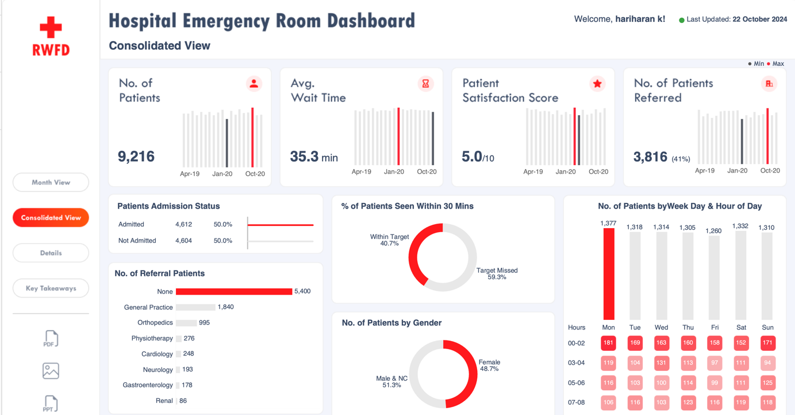

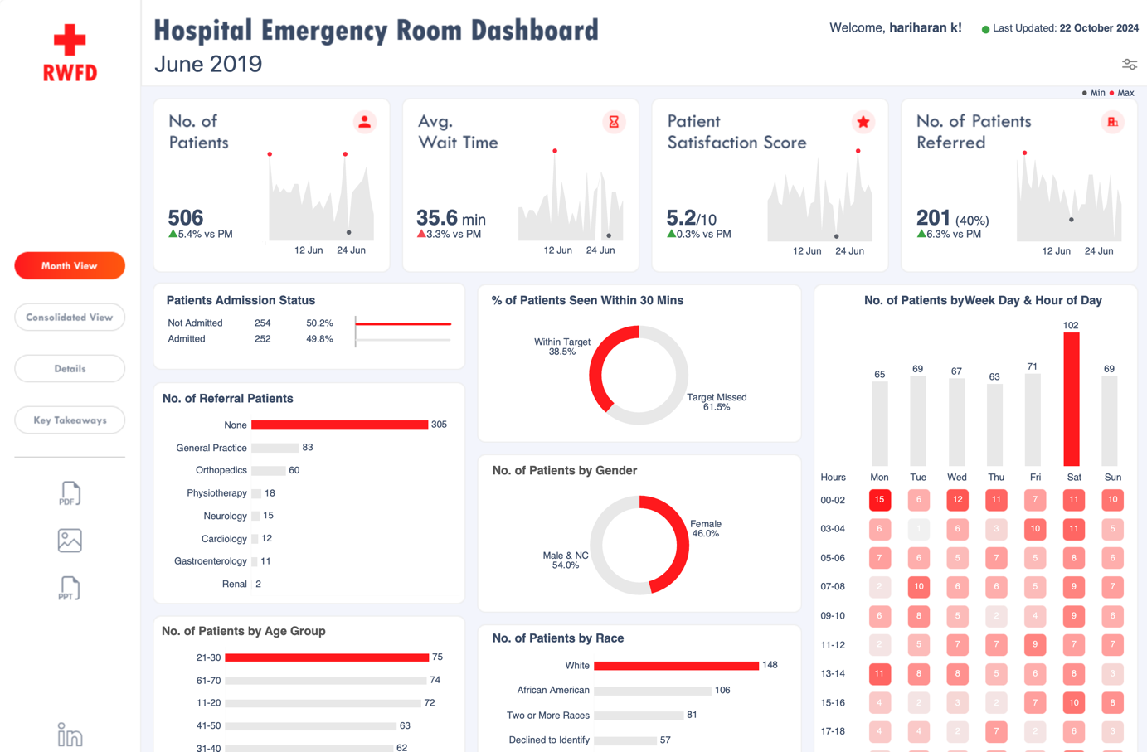

**CONCLUSION**

The Hospital Emergency Room Dashboard serves as a crucial tool for improving transparency and understanding of emergency care quality across various hospitals in the United States. By integrating comprehensive data visualizations, including pie charts, bar charts, and stacked bar charts, the dashboard effectively communicates key performance metrics to a diverse audience, including healthcare administrators, policymakers, and the general public.

Meticulous data preprocessing steps were undertaken, such as handling missing values, detecting outliers, filtering irrelevant data, standardizing date formats, and normalizing variables. These efforts ensured that the data used for analysis was of high quality and reliability. This foundational work enables stakeholders to make informed, data-driven decisions based on accurate insights.

The dashboard highlights emergency room performance metrics, patient wait times, care outcomes, and patient satisfaction ratings while providing a platform for identifying trends and performance gaps in emergency healthcare delivery. By facilitating easy comparisons and visual exploration of data, the dashboard empowers users to monitor emergency room performance, enhance patient care, and drive strategic improvements in the healthcare system.

**REFERENCES**

* D. D. Asch, et al. (2004). "The Role of Quality Measurement in Improving Emergency Care." *Journal of the American Medical Association*. <https://jamanetwork.com/journals/jama/fullarticle/199490>
* H. Chen, et al. (2016). "Data Visualization in Emergency Healthcare: A Systematic Review." *Journal of the American Medical Informatics Association*. <https://academic.oup.com/jamia/article/23/6/1242/2454397>
* S. L. C. Ancker, et al. (2017). "Using Health Data Visualization to Enhance Quality of Emergency Care: A Systematic Review." *Journal of Healthcare Quality*. <https://journals.lww.com/jhquality/Abstract/2017/11000/Use_of_Health_Data_Visualization_to_Improve.7.aspx>
* K. L. G. M. P. D. B. Coiera, et al. (2019). "Designing Data Visualization for Emergency Health Data: Principles and Methods." *International Journal of Medical Informatics*. <https://www.sciencedirect.com/science/article/pii/S1386505618304878>
* K. J. O. R. D. S. Lee, et al. (2020). "Emergency Room Performance Metrics: A Review of the Literature." *BMC Health Services Research*. <https://bmchealthservres.biomedcentral.com/articles/10.1186/s12913-020-05312-2>

**EVALUATION SHEET**

### Reg no: URK22AI1048

### Name: HARIHARAN K

### Course code: 20CS2014

### Course Name: Data Visualization

|  |  |  |  |
| --- | --- | --- | --- |
| **S.no** | **Rubrics** | **Maximum Marks** | **Marks obtained** |
| **1** | **Online Certification Completion** | **10** |  |
| **2** | **Evaluation of Problem statement and Dataset** | **10** |  |
| **3** | **Methodology Implementation** | **10** |  |
| **4** | **Result Analysis** | **5** |  |
| **5** | **Report** | **5** |  |
| **Total** |  | **40** |  |

**Signature of the Faculty-in-charge**

### Signature of the Examiner